**Assignment Day 6**

**Question 1:**

* Create payload for windows .

● Transfer the payload to the victim's machine.

● Exploit the victim's machine.

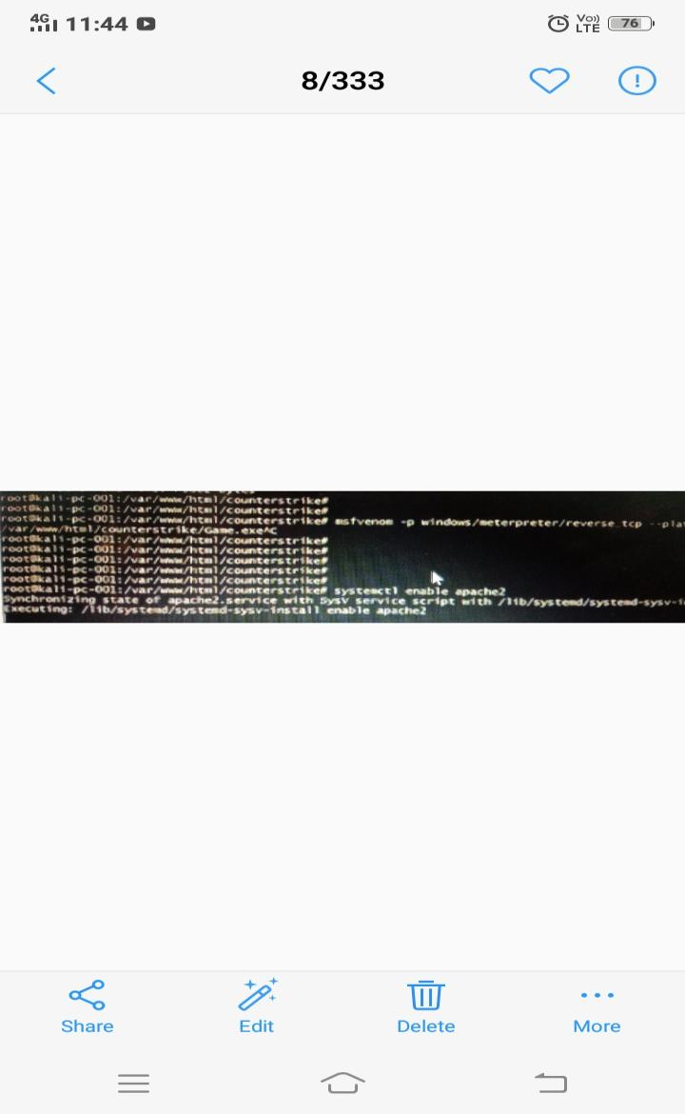

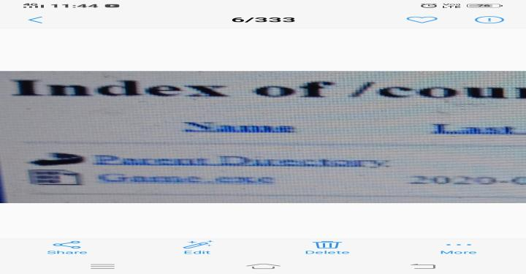

**Question 2:**

* Create an FTP server

● Access FTP server from windows command prompt

● Do an mitm and username and password of FTP transaction using wireshark and dsniff.

